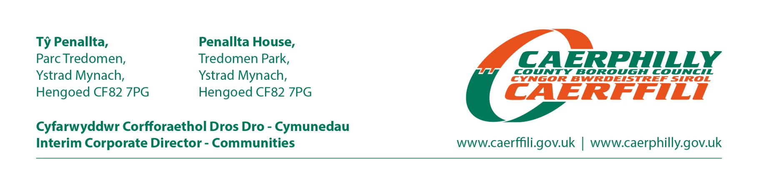
Parent/Guardian | Contact/Cysylltwch a: Clare Rogers
Parent/Guardian | Phone/Ffôn: 01443 864055
Parent/Guardian | Your Ref/Eich Cyf:
Parent/Guardian | Date: 25 March 2022
Dear Parent / Guardian,
CASHLESS CATERING SYSTEM
We are pleased to announce that the school that your child will be attending has an online payment www.upay.co.uk cashless catering system, which will make school break / lunch times easier for your child.

This system will enable us to continue to provide healthy and enjoyable meals whilst providing other benefits such as:

- Easy online payment solution which allows you to manage and pay for your child’s meals through the following website: www.upay.co.uk;

- Ability to view statements, check balances and see a history of your child’s purchases;

- Smartphone App – download the upay app to your smartphone and make payments for your child’s school food;

- Auto tops – Use this feature to configure your child’s account so that every time the balance reaches a pre-set minimum, a pre-set top up amount is automatically added to your child’s account;

- Less opportunity for bullying as there is nothing to be stolen for use by other students;

- No obvious difference between pupils who pay for meals and free school meal pupils;

- Reduction in queuing time.

To register your child’s online account you will need the following information

Your Company’s Affiliate ID: CBCS
Your Child’s Name:
Your User ID:

Please visit www.upay.com and follow the instructions on the website to register your child’s account.

For more information on the cashless system, please call 01443 864055 or visit our website: www.caerphilly.gov.uk and type cashless catering into the search field.

If you require any further information please telephone Catering Services Head Office on 01443 864055 or Catering@caerphilly.gov.uk.

Yours Sincerely

Marcia Lewis
Principal Officer Catering

